Titanium Man
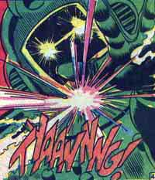
Real Name: Boris ... er, "Bullski"
AKA: Boris the Merciless. The Other. The Commander.
First Appearance: Tales of Suspense 69
Died In: Thor 358, and again after a bout with Iron Man. (The Titanium Man that died during "the Armor Wars" in Iron Man 229 was the Gremlin, who used a version of the Titanium Man's armor).
Resurrected In: Secret Defenders 12, when Thanos needed a few unscrupulous men for a special assault force. Whether Bullski was actually recreated after the card containing his molecular info was torn up (don't ask) or whether he was simply snatched out of time is hard to say. He was also brought back to life in Soviet Super Soldiers 1, when the Crimson Dynamo need a few dead Soviets; the Crimson Dynamo later destroyed him once again.
What's His Problem? An ardent and ambitious member of the Communist party, Bullski conceived the idea of Titanium Man as a response to the capitalist hero Iron Man, reasoning that defeating the Golden Avenger was as good a way as any of advancing himself politically. Ideological differences aside, Iron Man had the better suit and trashed Titanium Man at every meeting.
Abilities: Following initial well-publicized defeats, Bullski submitted to Half Face's biological enhancements. While increasing his physical strength and size, it still didn't net him the much-desired victory over Iron Man. Most of Bullski's capabilities really belong to the suit. Nuclear powered, the flight-capable armor fires lasers and greatly increases Bullski's already-inhuman strength.
Heroes He Kept Running Into: Like calls to like; the Titanium Man came into being as a combatant for Iron Man, his most frequent foe. He also battled Beta Ray Bill during one of his two fatal combats.
Favorite Quote: "So, my oldest enemy comes to battle me again, does he? Good! Your defeat shall lie as icing on the cake of my total victory!" (Iron Man 135. Guess Boris skipped dessert and couldn't stop thinking about it...)
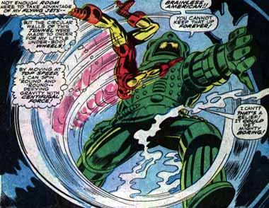
People Who Think He's Not So Bad: Bullski was a member of the Titanic Three, along with the Crimson Dynamo and Radioactive Man. Although the Three seemed to get along, that gig was short lasting. Bullski himself owed a debt of gratitude to the Chinese scientist he knew only as Half-Face after being first rescued and then reconstructed by him. The Unicorn so worshipped the Titanium Man that he accidentally drowned while trying to return to his beloved master, even though Boris was only using him to test the strength of Iron Man's new armor. Under the guise of the Commander, Bullski founded the Green Liberation Front, an organization of disgruntled Viet Nam vets that liked him well enough until they discovered he was a Soviet agent using the Front as a ... well, front.
Most Despicable Act: Let's see...he shot the unarmed Happy Hogan with the Russian equivalent of a repulsor ray; tried to raze a helpless village and pin the blame on American imperialists; wrecked New York and tossed around a few civilians; basically, Bullski's just an over-sized, power-mad, titanium-plated bully who prefers to beat up on those who can't possibly fight back!

